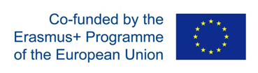

Sustainable development of Blue economies through higher education and innovation in Western Balkan Countries – BLUEWBC

Project no. 609693-EPP-1-2019-1-NO-EPPKA2-CBHE-JP
www.bluewbc.eu

Type of document: | Report, Minutes, etc.
Workpackage: | WP1 – Title of the WP
Deliverable: | Dev. 1.1 – Title of the Deliverable
Lead partner: | Name of the partner institution
Participating partners: | Name of the partner institution
Contact: | Name and title of the contact person(s), contact e-mail address
Date: | Date of the creation
Approved by: | QAB, PMB

Disclaimer:
The European Commission's support for the production of this publication does not constitute an endorsement of the contents, which reflect the views only of the authors, and the Commission cannot be held responsible for any use which may be made of the information contained therein.

Table of contents
Introduction 2
CHAPTER 1: Educational programs for I&E in Blue economy in EU 3
CHAPTER 2: Innovation and entrepreneurship in Norway 4
Study programs in Norway 5
Conclusion 6
Annexes 7

This document has been prepared and published through the BLUEWBC project. Therefore, this document and its contents remain the property of the BLUEWBC Consortium.

